Dynamic weather info update based on location

Month and year info

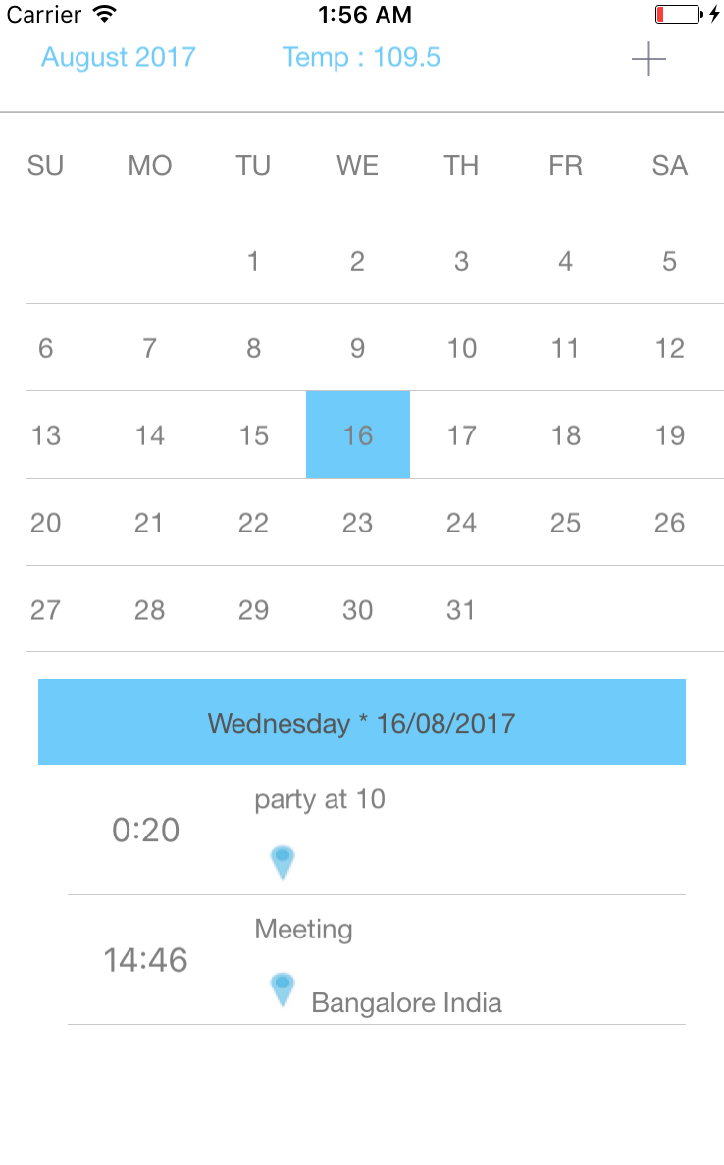

List of Events, With name, time & Location

Event Day info

Calendar control

Icon to add new event

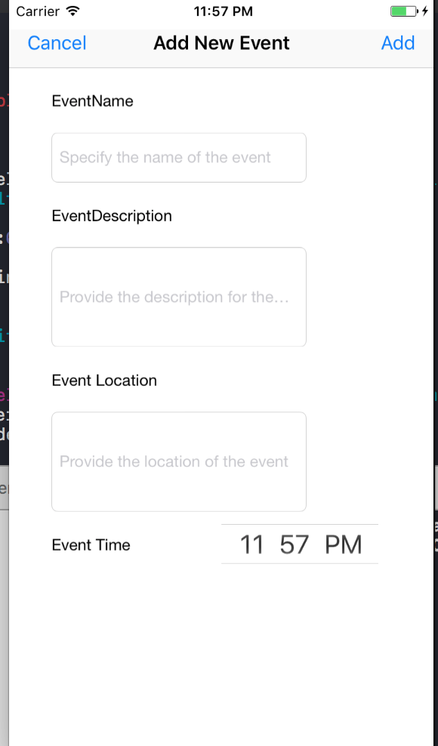

Allows user to create a new event on a specific day with time and location preferences